

**CONTENTS**

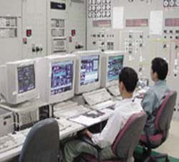**Economics of Power Generation**

C H A PTER

*4*

# Introduction

* 1. **Economics of Power Generation**
  2. **Cost of Electrical Energy**
  3. **Expressions for Cost of Electrical Energy**
  4. **Methods of Determining Depreciation**
  5. **Importance of High Load Factor**

A

power station is required to deliver power to a large number of consumers to meet their requirements. While de-

signing and building a power station, efforts should be made to achieve overall economy so that the per unit cost of production is as low as possible. This will enable the electric supply company to sell electrical energy at a profit and ensure reliable service. The problem of deter- mining the cost of production of electrical en- ergy is highly complex and poses a challenge to power engineers. There are several factors which influence the production cost such as cost of land and equipment, depreciation of equipment, inter- est on capital investment etc. Therefore, a care- ful study has to be made to calculate the cost of production. In this chapter, we shall focus our attention on the various aspects of economics of power generation.

# Economics of Power Generation

*The art of determining the per unit (i.e., one kWh) cost of production of electrical energy is known as* **economics of power generation.**

The economics of power generation has as- sumed a great importance in this fast developing

**69**



**CONTENTS**

power plant engineering. A consumer will use electric power only if it is supplied at reasonable rate. Therefore, power engineers have to find convenient methods to produce electric power as cheap as possible so that consumers are tempted to use electrical methods. Before passing on to the subject further, it is desirable that the readers get themselves acquainted with the following terms much used in the economics of power generation :

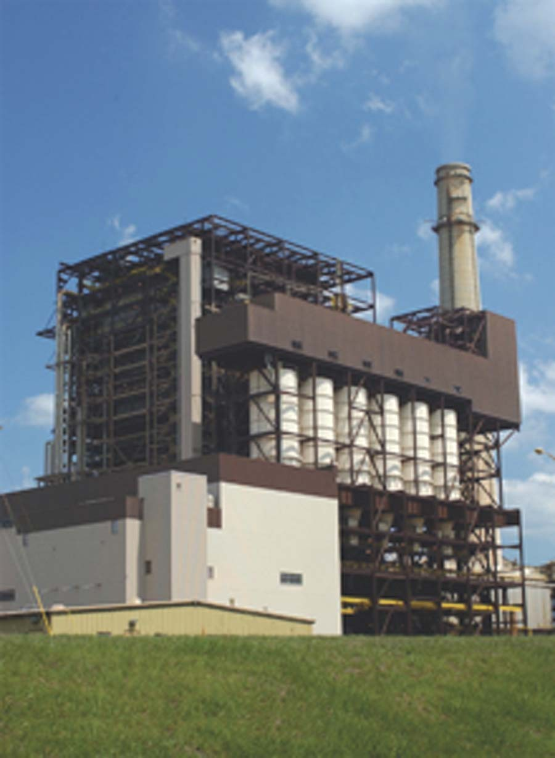

1. **Interest.** *The cost of use of money is known as* **interest.**

A power station is constructed by investing a huge capital. This money is generally borrowed from banks or other financial institutions and the supply company has to pay the annual interest on this amount. Even if company has spent out of its reserve funds, the interest must be still allowed for, since this amount could have earned interest if deposited in a bank. Therefore, while calculating the cost of production of electrical energy, the interest payable on the capital investment must be in- cluded. The rate of interest depends upon market position and other factors, and may vary from 4% to 8% per annum.

1. **Depreciation.** *The decrease in the value of the power plant equipment and building due to constant use is known as* **depreciation.**

If the power station equipment were to last for ever, then interest on the capital investment would have been the only charge to be made. However, in actual practice, every power station has a useful life ranging from fifty to sixty years. From the time the power station is installed, its equipment steadily deteriorates due to wear and tear so that there is a gradual reduction in the value of the plant. This reduction in the value of plant every year is known as *annual depreciation*. Due to depreciation, the plant has to be replaced by the new one after its useful life. Therefore, suitable amount must be set aside every year so that by the time the plant retires, the collected amount by way of depreciation equals the cost of replacement. It becomes obvious that while determining the cost of production, annual depreciation charges must be included. There are several methods of finding the annual depreciation charges and are discussed in Art. 4.4.

# Cost of Electric al Energy

The total cost of electrical energy generated can be divided into three parts, namely ;

* + 1. Fixed cost ; **(*ii*)** Semi-fixed cost ; **(*iii*)** Running or operating cost.

1. **Fixed cost.** *It is the cost which is independent of maximum demand and units generated.*

The fixed cost is due to the *annual cost of central organisation*, *interest on capital cost of land* and *salaries of high officials*. The annual expenditure on the central organisation and salaries of high officials is fixed since it has to be met whether the plant has high or low maximum demand or it generates less or more units. Further, the capital investment on the land is fixed and hence the amount of interest is also fixed.

1. **Semi-fixed cost.** *It is the cost which depends upon maximum demand but is independent of units generated.*

The semi-fixed cost is directly proportional to the maximum demand on power station and is on account of *annual interest and depreciation on capital investment of building and equipment, taxes, salaries of management and clerical staff*. The maximum demand on the power station determines its size and cost of installation. The greater the maximum demand on a power station, the greater is its size and cost of installation. Further, the taxes and clerical staff depend upon the size of the plant and hence upon maximum demand.

1. **Running cost.** *It is the cost which depends only upon the number of units generated.*

The running cost is on account of *annual cost of fuel, lubricating oil, maintenance, repairs* and *salaries of operating staff*. Since these charges depend upon the energy output, the running cost is directly proportional to the number of units generated by the station. In other words, if the power station generates more units, it will have higher running cost and *vice-versa*.

Economics of Power Generation **71**

# Expressions for Cost of Electric al Energy

The overall annual cost of electrical energy generated by a power station can be expressed in two forms *viz three part form* and *two part form*.

* + 1. **Three part form.** In this method, the overall annual cost of electrical energy generated is divided into three parts *viz* fixed cost, semi-fixed cost and running cost *i.e.*

Total annual cost of energy = Fixed cost + Semi-fixed cost + Running cost

= Constant + Proportional to max. demand + Proportional to kWh generated.

= Rs (*a* + *b* kW + *c* kWh)

where *a* = annual fixed cost independent of maximum demand and en- ergy output. It is on account of the costs mentioned in Art. 4.2.

*b* = constant which when multiplied by maximum kW demand on the station gives the annual semi-fixed cost.

*c* = a constant which when multiplied by kWh output per annum gives the annual running cost.

* + 1. **Two part form.** It is sometimes convenient to give the annual cost of energy in two part form. In this case, the annual cost of energy is divided into two parts *viz.,* a fixed sum per kW of maximum demand *plus* a running charge per unit of energy. The expression for the annual cost of energy then becomes :

Total annual cost of energy = Rs. (*A* kW + *B* kWh)

where *A* = a constant which when multiplied by maximum kW demand on the station gives the annual cost of the first part.

*B* = a constant which when multiplied by the annual kWh gener- ated gives the annual running cost.

It is interesting to see here that two-part form is a simplification of three-part form. A little reflection shows that constant “*a*” of the three part form has been merged in fixed sum per kW maximum demand (*i.e.* constant *A* ) in the two-part form.

# Methods of Deter mining Depreciation

There is reduction in the value of the equipment and other property of the plant every year due to depreciation. Therefore, a suitable amount (known as *depreciation charge*) must be set aside annu- ally so that by the time the life span of the plant is over, the collected amount equals the cost of replacement of the plant.

The following are the commonly used methods for determining the annual depreciation charge :

* + 1. Straight line method ;
    2. Diminishing value method ;
    3. Sinking fund method.
       1. **Straight line method.** In this method, a constant depreciation charge is made every year on the basis of total depreciation and the useful life of the property. Obviously, annual depreciation charge will be equal to the total depreciation divided by the useful life of the property. Thus, if the initial cost of equipment is Rs 1,00,000 and its scrap value is Rs 10,000 after a useful life of 20 years, then,

Annual depreciation charge = Total depreciation  1,00,000  10,000 = Rs 4,500

Useful life 20

In general, the annual depreciation charge on the straight line method may be expressed as :

**72** Prin ciples of Power System

Annual depreciation charge = *P*  *S*

*n*

where *P* = Initial cost of equipment

*n* = Useful life of equipment in years

*S* = Scrap or salvage value after the useful life of the plant.



The straight line method is extremely simple and is easy to apply as the annual depreciation charge can be readily calculated from the total depreciation and useful life of the equipment. Fig. 4.1 shows the graphical repre- sentation of the method. It is clear that initial value *P* of the equipment reduces uniformly, through depreciation, to the scrap value *S* in the useful life of the equipment. The depreciation curve (*PA* ) follows a straight line path, indicating constant annual depreciation charge. However, this method suffers from two defects. Firstly, the assump- tion of constant depreciation charge every year is not cor- rect. Secondly, it does not account for the interest which may be drawn during accumulation.

* + - 1. **Diminishing value method.** In this method, depreciation charge is made every year at a fixed rate on

the diminished value of the equipment. In other words, depreciation charge is first applied to the initial cost of equipment and then to its diminished value. As an example, suppose the initial cost of equipment is Rs 10,000 and its scrap value after the useful life is zero. If the annual rate of depreciation is 10%, then depreciation charge for the first year will be 0·1  10,000 = Rs 1,000. The value of the equipment is diminished by Rs 1,000 and becomes Rs 9,000. For the second year, the depreciation charge will be made on the diminished value (*i.e.* Rs 9,000) and becomes 0·1  9,000 = Rs 900. The value of the equipment now becomes 9000  900 = Rs 8100. For the third year, the depreciation charge will be 0·1  8100 = Rs 810 and so on.

## Mathematical treatment

Let *P* = Capital cost of equipment

*n* = Useful life of equipment in years

*S* = Scrap value after useful life

Suppose the annual unit* depreciation is *x*. It is desired to find the value of *x* in terms of *P*, *n* and

*S*.

Value of equipment after one year

= *P*  *Px* = *P* (1  *x*) Value of equipment after 2 years

= Diminished value  Annual depreciation

= [*P*  *Px*]  [(*P*  *Px*)*x*]

= *P*  *Px*  *Px* + *Px*2

= *P*(*x*2  2*x* + 1)

= *P*(1  *x*)2

 Value of equipment after *n* years

= *P*(1  *x*)*n*

* If annual depreciation is 10%, then we can say that annual unit depreciation is 0·1.

Economics of Power Generation **73**

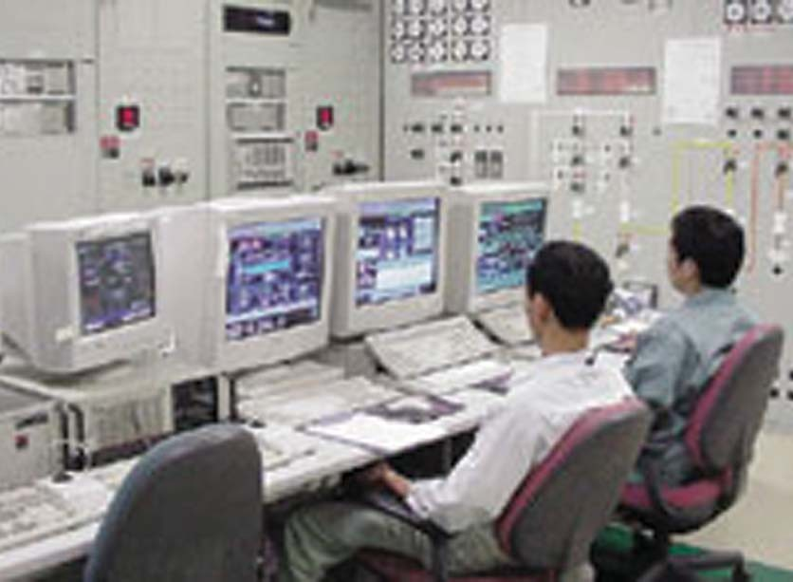But the value of equipment after *n* years (*i.e.,* useful life) is equal to the scrap value *S*.

|  |  |  |  |
| --- | --- | --- | --- |
|  |  | *S* | = *P*(1  *x*)*n* |
| or |  | (1  *x*)*n* | = *S*/*P* |
| or |  | 1  *x* | = (*S*/*P*)1/*n* |
| or |  | *x* | = 1  (*S*/*P*)1/*n* |

...(*i*)

From exp. (*i*), the annual depreciation can be easily found. Thus depreciation to be made for the first year is given by :

Depreciation for the first year = *xP*



= *P*[1  (*S*/*P*)1/*n*]

Similarly, annual depreciation charge for the subsequent years can be calculated.

This method is more rational than the straight line method. Fig. 4.2 shows the graphical representation of diminishing value method. The initial value *P* of the equipment reduces, through depreciation, to the scrap value *S* over the useful life of the equipment. The depreciation curve follows the path *PA* . It is clear from the curve that depreciation charges are heavy in the early years but decrease to a low value in the later years. This method has two drawbacks. Firstly, low depre- ciation charges are made in the late years when the mainte- nance and repair charges are quite heavy. Secondly, the de- preciation charge is independent of the rate of interest which it may draw during accumulation. Such interest moneys, if earned, are to be treated as income.

* + - 1. **Sinking fund method.** In this method, a fixed depreciation charge is made every year and interest compounded on it annually. The constant depreciation charge is such that total of annual instalments plus the interest accumulations equal to the cost of replacement of equipment after its useful life.

Let *P* = Initial value of equipment

*n* = Useful life of equipment in years

*S* = Scrap value after useful life

*r* = Annual rate of interest expressed as a decimal Cost of replacement = *P*  *S*

Let us suppose that an amount of *q* is set aside as depreciation charge every year and interest compounded on it so that an amount of *P*  *S* is available after *n* years. An amount *q* at annual interest rate of *r* will become \**q*(1 + *r*)*n* at the end of *n* years.

Now, the amount *q* deposited at the end of first year will earn compound interest for *n*  1 years and shall become *q*(1 + *r*)*n*  1 *i.e.,*

Amount *q* deposited at the end of first year becomes

= *q* (1 + *r*)*n*  1

* This can be easily proved.

At the end of first year, amount is = *q* + *rq* = *q*(1 + *r*)

At the end of second year, amount is = (*q* + *rq*) + *r*(*q* + *rq*) = *q* + *rq* + *rq* + *r*2*q*

Similarly, at the end of *n* years, amount is = *q*(1 + *r*)*n*

**74** Prin ciples of Power System



Amount *q* deposited at the end of 2nd year becomes

= *q* (1 + *r*)*n*  2

Amount *q* deposited at the end of 3rd year becomes

= *q* (1 + *r*)*n*  3

Similarly amount *q* deposited at the end of *n*  1 year becomes

= *q* (1 + *r*)*n*  (*n*  1)

= *q* (1 + *r*)

 Total fund after *n* years = *q* (1 + *r*)*n*  1 + *q* (1 + *r*)*n*  2 + + *q* (1 + *r*)

= *q* [(1 + *r*)*n*  1 + (1 + *r*)*n*  2 + + (1 + *r*)]

This is a G.P. series and its sum is given by :

*q*(1  *r*)*n*  1

Total fund = *r*

This total fund must be equal to the cost of replacement of equipment *i.e., P*  *S*.

 *P*  *S* =

(1  *r*)*n*  1

*q r*

or Sinking fund, *q* = (*P*  *S*) LM *r* O

P

*n*

...(*i*)

N(1  *r*)  1Q

The value of *q* gives the uniform annual depreciation charge. The paraenthetical term in eq. (*i*) is frequently referred to as the “sinking fund factor”.

 Sinking fund factor = *r*

(1  *r*)*n*  1

Though this method does not find very frequent application in practical depreciation accounting, it is the fundamental method in making economy studies.

**Example 4.1.** *A transformer costing Rs 90,000 has a useful life of 20 years. Determine the annual depreciation charge using straight line method. Assume the salvage value of the equipment to be Rs 10,000.*

## Solution :

Initial cost of transformer, *P* = Rs 90,000 Useful life, *n* = 20 years

Salvage value, *S* = Rs 10,000 Using straight line method,

Annual depreciation charge = *P*  *S*  Rs 90,000  10,000 = **Rs 4000**

*n* 20

**Example 4.2.** *A distribution transformer costs Rs 2,00,000 and has a useful life of 20 years. If the salvage value is Rs 10,000 and rate of annual compound interest is 8%, calculate the amount to be saved annually for replacement of the transformer after the end of 20 years by sinking fund method.*

## Solution :

Initial cost of transformer, *P* = Rs 2,00,000 Salvage value of transformer, *S* = Rs 10,000 Useful life, *n* = 20 years

Annual interest rate, *r* = 8% = 0·08 Annual payment for sinking fund,

Economics of Power Generation **75**

*q* = (*P*  *S*) LM

*r n* OP

N(1  *r*)  1Q

= (2,00,000  10,000) LM 0  08 OP

N(1  0  08)20  1Q

= 1,90,000 L 0  08 O = **Rs 4153**

MN PQ

4  66  1

**Example 4.3.** *The equipment in a power station costs Rs 15,60,000 and has a salvage value of Rs 60,000 at the end of 25 years. Determine the depreciated value of the equipment at the end of 20 years on the following methods :*

1. Straight line method ;
2. Diminishing value method ;
3. Sinking f*und method at 5% compound interest annually.*

## Solution :

Initial cost of equipment, *P* = Rs 15,60,000 Salvage value of equipment, *S* = Rs 60,000 Useful life, *n* = 25 years

1. *Straight line method*

Annual depreciation = *P*  *S*  Rs 15,60,000  60,000 = Rs 60,000

*n* 25

Value of equipment after 20 years

1. *Diminishing value method*

= *P*  Annual depreciation  20

= 15,60,000  60,000  20 = **Rs 3,60,000**

Annual unit depreciation, *x* = 1  (*S*/*P*)1/*n*

F 60,000 I1/ 25

= 1  H15,60,000K = 1  0·878 = 0·122

Value of equipment after 20 years

= *P*(1  *x*)20

= 15,60,000 (1  0·122)20 = **Rs 1,15,615**

1. *Sinking fund method*

Rate of interest, *r* = 5% = 0·05 Annual deposit in the sinking fund is

*q* = (*P*  *S*) LM *r* OP

*n*

N(1  *r*)  1Q

= (15,60,000  60,000) L 0  05 O

MN PQ

(1  0  05)25  1

= Rs 31,433

 Sinking fund at the end of 20 years

(1  *r*)20  1

= *q r*

 31,433

(1  0  05)20  1

0  05

= Rs 10,39,362

Value of plant after 20 years = Rs (15,60,000  10,39,362) = **Rs 5,20,638**

**76** Prin ciples of Power System

# Importance of High Load Fa ctor

The load factor plays a vital role in determining the cost of energy. Some important advantages of high load factor are listed below :

* + 1. *Reduces cost per unit generated* : A high load factor reduces the overall cost per unit generated. The higher the load factor, the lower is the generation cost. It is because higher load factor means that for a given maximum demand, the number of units generated is more. This reduces the cost of generation.
    2. *Reduces variable load problems* : A high load factor reduces the variable load problems on the power station. A higher load factor means comparatively less variations in the load demands at various times. This avoids the frequent use of regulating devices installed to meet the variable load on the station.

**Example 4.4.** *A generating station has a maximum demand of 50,000 kW. Calculate the cost*

*per unit generated from the following data :*

*Capital cost = Rs 95*  *106 ; Annual load factor = 40%*

*Annual cost of fuel and oil = Rs 9*  *106 ; Taxes, wages and salaries etc. = Rs 7·5*  *106 Interest and depreciation = 12%*

## Solution :

Units generated/annum = Max. demand  L.F.  Hours in a year

= (50,000)  (0·4)  (8760) kWh = 17·52  107 kWh

## Annual fixed charges

Annual interest and depreciation = 12% of capital cost

= Rs 0·12  95  106 = Rs 11·4  106

## Annual Running Charges

Total annual running charges = Annual cost of fuel and oil + Taxes, wages etc.

= Rs (9  106 + 7·5  106) = Rs 16·5  106

Total annual charges = Rs (11·4  106 + 16·5  106) = Rs 27·9  106

 Cost per unit = Rs 27  9  106 17  52  107

= Re 0·16 = **16 paise**

**Example 4.5.** *A generating station has an installed capacity of 50,000 kW and delivers 220*  *106 units per annum. If the annual fixed charges are Rs 160 per kW installed capacity and running charges are 4 paise per kWh, determine the cost per unit generated.*

## Solution :

Annual fixed charges = 160  Plant capacity

= Rs 160  50,000 = Rs 80  105

Annual running charges = Rs 0·04  220  106 = Rs 88  105

Total annual charges = Rs (80  105 + 88  105) = Rs 168  105

Cost per unit = Rs 168  105

220  106

= Re 0·0764 = **7·64 paise**

**Example 4.6.** *A generating plant has a maximum capacity of 100 kW and costs Rs 1,60,000. The annual fixed charges are 12% consisting of 5% intererst, 5% depreciation and 2% taxes. Find the fixed charges per kWh if the load factor is (i) 100% and (ii) 50%.*

## Solution :

Maximum demand = 100 kW

Annual fixed charges = Rs 0·12  1,60,000 = Rs 19,200

Economics of Power Generation **77**

1. *When load factor is 100%*

Units generated/annum = Max. demand  L.F.  Hours in a year

= 100  1  8760 = 8,76,000 kWh

Fixed charges/kWh = Rs 19,200 = Rs 0·0219 = **2·19 paise**

8,76,000

1. *When load factor is 50%*

Units generated/annum = 100  0·5  8760 = 4,38,000 kWh

Fixed charges/kWh = Rs 19,200 = Re 0·0438 = **4·38 paise**

4,38,000

It is interesting to note that by decreasing the load factor from 100% to 50%, the fixed charges/ kWh have increased two-fold. Incidentally, this illustrates the utility of high load factor.

**Example 4.7.** *Estimate the generating cost per kWh delivered from a generating station from*

*the following data :*

*Plant capacity = 50 MW ;Annual load factor = 40%*

*Capital cost = 1·2 crores ; annual cost of wages, taxation etc. = Rs 4 lakhs ; cost of fuel, lubrication, maintenance etc. = 1·0 paise/kWh generated. Interest 5% per annum, depreciation 6% per annum of initial value.*

**Solution :** The maximum demand on the station may be assumed equal to the plant capacity *i.e.*, 50 MW.

## Annual fixed charges

Interest and depreciation = Rs 120  105  (5 + 6)/100 = Rs 13·2  105 Wages and taxation = Rs 4  105

Total annual fixed charges = Rs (13·2  105 + 4  105) = Rs 17·2  105

## Annual running charges

Units generated/annum = Max. demand  L.F.  Hours in a year

= (50  103)  (0·4)  (8760) kWh

= 1752  105 kWh

Cost of fuel, lubrication etc. = Rs 1752  105  0·01 = Rs 17·52 105

Total annual charges = Rs (17·2  105 + 17·52  105) = Rs 34·72  105

34  72  105

 Cost per kWh = Rs 1752  105

= Re 0·02 = **2 paise**

**Example 4.8.** *A generating station has the following data :*

*Installed capacity = 300 MW ; Capacity factor = 50% ; Annual load factor = 60%*

*Annual cost of fuel, oil etc. = Rs 9*  *107 ; capital cost = Rs 109 ; annual interest and deprecia- tion = 10%. Calculate* (*i*) *the minimum reserve capacity of the station and* (*ii*) *the cost per kWh generated.*

## Solution :

1. Capacity factor, C.F. = Average demand

Installed capacity

Load factor, L.F. = Average demand

Max. demand

...(*i*)

...(*ii*)

Dividing (*i*) by (*ii*), we get,

C. F.

L. F.

= Max. demand Installed capacity

**78** Prin ciples of Power System

or Max. demand = Installed capacity  C. F. = 300  0  5 = 250 MW

L. F.

 Reserve capacity = 300  250 = **50 MW**

0  6

1. Units generated/annum = Max. demand  L.F.  Hours in a year

= (250  103)  (0·6)  8760 kWh = 1314  106 kWh

Annual fixed charges = Annual interest and depreciation

= Rs 0·1  109 = Rs 108

Annual running charges = Rs 9  107

 Total annual charges = Rs (108 + 9  107) = Rs 19  107

 Cost per kWh = Rs 19  107

1314  106

= Re 0·14 = **14 paise**

**Example 4.9.** *The capital cost of a hydro-power station of 50 MW capacity is Rs 1,000 per kW. The annual depreciation charges are 10% of the capital cost. A royalty of Re 1 per kW per year and Re 0·01 per kWh generated is to be paid for using the river water for generation of power. The maximum demand on the power station is 40 MW and annual load factor is 60%. Annual cost of salaries, maintenance charges etc. is Rs 7,00,000. If 20% of this expense is also chargeable as fixed charges, calculate the generation cost in two part form.*

## Solution :

Units generated/annum = (40  103)  (0·6)  8760 = 210·24  106 kWh Capital cost of plant = Rs 50  103  1000 = Rs 50  106

## Annual fixed charges

Depreciation = Rs 0·1  50  106 = Rs 5  106 Salaries, maintenance etc. = Rs 0·2  7,00,000 = Rs 1·4  105

Total annual fixed charges = Rs (5  106 + 1·4  105) = Rs 51·4  105 Cost per kW = Cost per kW due to fixed charges + Royalty

## Annual running charges

= Rs 51 4  105

40  103

+ Re 1 = Rs 128·5 + Re 1 = Rs 129·5

Salaries, maintenance etc. = Rs 0·8  7,00,000 = Rs 5·6  105

Cost per kWh = Cost/kWh due to running charges + Royalty

5  6  105

= Rs 210  24  106

 Re 0  01

= Re 0·0027 + Re 0·01 = Re 0·0127

 Total generation cost in two part form is given by ;

## Rs (129· 5  kW + 0·0127  kWh)

**Example 4.10.** *The annual working cost of a power station is represented by the formula Rs* (*a*

*+ b kW + c kWh*) *where the various terms have their usual meaning. Determine the values of a, b and c for a 60 MW station operating at annual load factor of 50% from the following data :*

1. *capital cost of building and equipment is Rs 5*  *106*
2. *the annual cost of fuel, oil, taxation and wages of operating staff is Rs 9,00,000*
3. *the interest and depreciation on building and equipment are 10% per annum*
4. *annual cost of organisation and interest on cost of site etc. is Rs 5,00,000.*

Economics of Power Generation **79**

**Solution :**

Units generated/annum = Max. demand  L.F.  Hours in a year

= (60  103)  (0·5)  (8760) kWh = 262·8  106 kWh

Annual operating cost = Rs (*a* + *b*  kW + *c*  kWh) where *a* = annual fixed cost

*b*  kW = annual semi-fixed cost

*c*  kWh = annual running cost

**Annual fixed cost.** The annual fixed cost is due to the annual cost of organisation and interest on the cost of site.

 *a* = **Rs 5,00,000**

**Annual semi-fixed cost.** This is on account of annual interest and depreciation on building and equipment.

Annual semi-fixed cost = Rs 0·1  5  106 = Rs 5,00,000

But annual semi-fixed cost is equal to *b*  kW where *b* is the cost per kW of maximum demand.

 *b*  60  103 = Rs 5,00,000

or *b* = Rs 5,00,000

60  103

= **Rs 8·34**

**Annual running cost.** This is due to the annual cost of fuel, oil, taxation, salaries of operating staff.

 *c*  kWh generated = Rs 9,00,000

or *c*  262·8  106 = Rs 9,00,000

 *c* = Rs 9,00,000 = **Re 0·0034**

262  8  106

**Example 4.11.** *A hydro-electric plant costs Rs 3000 per kW of installed capacity. The total annual charges consist of 5% as interest ; depreciation at 2%, operation and maintenance at 2% and insurance, rent etc. 1·5%. Determine a suitable two-part tariff if the losses in transmission and distribution are 12·5% and diversity of load is 1·25. Assume that maximum demand on the station is 80% of the capacity and annual load factor is 40%. What is the overall cost of generation per kWh?*

**Solution :** Let the installed capacity of the station be 100 kW. Maximum demand = 100  0·8 = 80 kW

Average demand = 80  0·4 = 32 kW

Capital cost of plant = Rs 100  3000 = Rs 3  105

**Annual fixed charges.** The annual fixed charges are due to interest (5%) and depreciation (2%).

 Annual fixed charges = Rs 3  105  (5 + 2)/100 = Rs 21000 Aggregate of max. demand = 80  1·25 = 100 kW

 Annual fixed charges = Rs 21000/100 = Rs 210 per kW of max. demand

**Annual running charges.** The annual running charges are due to operation and maintenance (2%) and insurance, rent (1·5%) etc.

Annual running charges = Rs 3  105  (2 + 1·5)/100 = Rs 10,500 Units generated/annum = Average demand  Hours in a year

= 32  8760 = 2,80,320 kWh

Units reaching the consumer = 2,80,320  0·875 = 2,45,280 kWh

 Annual running charge = Rs 10,500 = Re 0·043 per kWh

2,45,280

**80** Prin ciples of Power System

The generation cost in two-part form is

## Rs (210  kW + 0·043  kWh)

Total annual charges = Rs (21,000 + 10,500) = Rs 31,500

Cost per kWh = Rs 31,500 = Re 0·128 = **12·8 paise**

2,45,280

**Example 4.12.** *Compare the annual cost of supplying a factory load having a maximum de- mand of 1 MW and a load factor of 50% by energy obtained from* (*i*) *a private oil engine generating plant and* (*ii*) *public supply.*

1. *Private oil engine generating unit :*

*Capital cost = Rs 12*  *105 ; Cost of repair and maintenance = Rs 0·005 per kWh generated Cost of fuel = Rs 1600 per 1000 kg ; Interest and depreciation = 10% per annum*

*Fuel consumption = 0·3 kg/kWh generated ; Wages = Rs 50,000 per annum*

1. *Public supply company :*

*Rs 150 per kW of maximum demand plus 15 paise per kWh*

## Solution :

Units generated/annum = (1000)  (0·5)  8760 = 438  104 kWh

## Private oil engine generating plant

Annual fuel consumption = 0·3  438  104 = 13·14  105 kg

Annual cost of fuel = Rs 13·14  105  1600/1000 = Rs 21,02,400 Annual cost of repair and maintenance = Rs 0·005  438  104 = Rs 21,900

Annual wages = Rs 50,000

Annual interest and depreciation = Rs 0·1  12  105 = Rs 1,20,000

 Total annual charges = Rs (21,02,400 + 21,900 + 50,000 + 1,20,000)

## = Rs 22,94,300

1. **Public supply**

Annual fixed charges = Rs 150  1000 = Rs 1,50,000 Annual running charges = Rs 0·15  438  104 = Rs 6,57,000

Total annual charges = Rs (1,50,000 + 6,57,000) = **Rs 8,07,000**

|  |  |  |
| --- | --- | --- |
| **Example 4.13.** *A power station having a maximum demand of 100 MW has a load factor of 30% and is to be supplied by one of the following schemes :*   1. *a steam station in conjunction with a hydro-electric station, the latter supplying 100*  *106 kWh per annum with a maximum output of 40 MW.* 2. *a steam station capable of supplying the whole load.* 3. *a hydro-station capable of supplying the whole load.*   *Compare the overall cost per kWh generated, assuming the following data :* | | |
|  | *Steam* | *Hydro* |
| (*a*) *Capital cost*/*kW installed* | *Rs 1250* | *Rs 2500* |
| (*b*) *Interest and depreciation on capital investment* | *12%* | *10%* |
| (*c*) *Operating cost*/*kWh* | *5 paise* | *1·5 paise* |
| (*d*) *Transmission cost*/*kWh* | *negligible* | *0·2 paise* |
| **Solution :** |  |  |

Units generated/annum = Max. demand  L.F.  Hours in a year

= (100  103)  (0·3)  (8760) = 262·8  106 kWh

Economics of Power Generation **81**

## Steam station in conjunction with hydro station

Units supplied by hydro-station = 100  106 kWh

 Units supplied by steam station = (262·8  100)  106 = 162·8  106 kWh

Since the maximum output of hydro station is 40 MW, the balance 100  40 = 60 MW shall be supplied by steam station.

1. *Steam Station*

Capital Cost = Rs 60  103  1250 = Rs 75  106 Annual interest and depreciation = Rs 0·12  75  106 = Rs 9  106

Operating Cost = Rs 0·05  162·8  106 = Rs 8·14  106 Transmission cost = negligible

 Total annual cost = Rs (9 + 8·14)  106 = Rs 17·14  106

1. *Hydro station*

Capital Cost = Rs 2500  40  103 = Rs 100  106 Annual interest and depreciation = Rs 0·1  100  106 = Rs 10  106

Operating cost = Rs 0·015  100  106 = Rs 1·5  106 Transmission cost = Rs 0·002  100  106 = Rs 0·2  106 Total annual cost = Rs (10 + 1·5 + 0·2)  106 = Rs 11·7  106

Total annual charges for both steam and hydro stations

= Rs (17·14 + 11·7)  106 = Rs 28·84  106

 Overall cost/kWh = Rs 28  84  106 262 8  106

= Re 0·1097 = **10·97 paise**

## Steam station

Capital cost = Rs 1250  100  103 = Rs 125  106

Annual interest and depreciation = Rs 0·12  125  106 = Rs 15  106

Fixed charges/kWh = Rs 15  106

262 8  106

Operating cost/kWh = 5 paise Transmission cost/kWh = negligible

= Re 0·0571 = 5·71 paise

 Overall cost/kWh = 5·71 + 5 = **10·71 paise**

## Hydro station

Capital cost = Rs 2500  100  103 = Rs 250  106 Annual interest and depreciation = Rs 0·1  250  106 = Rs 25  106

 Fixed charges/kWh = Rs 25  106 262 8  106

= Re 0·0951 = 9·51 paise

Adding the operating cost/unit and transmission cost per unit, we get, Overall cost/kWh = 9·51 + 1·5 + 0·2 =**11·21 paise**

**Example 4.14.** *A load having a maximum value of 150 MW can be supplied either by a hydro- electric station or steam power plant. The costs are as follows :*

*Plant Capital cost per kW installed Operating cost per kWh Interest Steam Plant Rs 1600 Re 0·06 7%*

*Hydro Plant Rs 3000 Re 0·03 7% Calculate the minimum load factor above which the hydro-electric plant will be more economi-*

*cal.*

**82** Prin ciples of Power System



## Solution :

Maximum demand = 150 MW = 150  103 kW

Let the total number of units generated per annum be *x*.

## Steam plant

Capital cost = Rs 1600  150  103 = Rs 240  106 Annual interest = Rs 0·07  240  106 = Rs 16·8  106

16  8  106

Fixed cost/unit = Rs *x*

Running cost/unit = Re 0·06 (given)

 FG16  8  106   IJ

Total cost/unit = Rs H *x* 0 06K

## Hydro plant

...(*i*)

Capital cost = Rs 3000  150  103 = Rs 450  106 Annual interest = 0·07  450  106 = Rs 31·5  106

Fixed cost/unit = Re 31 5  106

*x*

Running cost/unit = Re 0·03 (given)

 FG31 5  106   IJ

Total cost/unit = Rs H *x* 0 03K

...(*ii*)

The overall cost per unit of steam plant will be equal to hydro plant if exp. (*i*) = exp (*ii*) *i.e.,*

16  8  106

*x*

 0  06

31 5  106

= *x*

 0  03

or 16·8  106 + 0·06 *x* = 31·5  106 + 0·03 *x*

 *x* = 14  7  106

0  03

= 490  106 kWh

It follows, therefore, that if the units generated per annum are more than 490  106, the hydro plant will be more economical.

 Load factor =

490  106

(150  103)  8760

 100 = **37·3%**

Therefore, the minimum load factor above which the hydro plant will be economical is 37·3%.

|  |  |  |
| --- | --- | --- |
|  | *Hydro* | *Steam* |
| *Capital cost*/*kW* | *Rs 2100* | *Rs 1200* |
| *Running cost*/*kWh* | *3·2 paise* | *5 paise* |
| *Interest and depreciation* | *7·5%* | *9%* |
| *Reserve capacity* | *33%* | *25%* |

**Solution :** Let *x* kW be the maximum demand. Let *y* be the annual load factor at which cost/unit of steam and hydro stations is the same.

**Example 4.15.** *A particular area can be supplied either by hydro station or steam station. The following data is available :*

1. *At what load factor would the overall cost be the same in both cases ?*
2. *What would be the cost of generating 40*  *106 units at this load factor ?*

 Units generated/annum = *x*  *y*  8760 = 8760 *xy* kWh

* 1. The installed capacity of steam station will be 1·25*x* kW (keeping 25% as reserve capacity), whereas the installed capacity of hydro station would be 1·33*x* kW (keeping 33% as reserve capacity).

Economics of Power Generation **83**

## Steam station

Capital cost = Rs 1200  1·25*x* = Rs 1500*x*

Interest and depreciation = Rs 0·09  1500*x* = Rs 135*x* Running cost/annum = Rs 0·05  8760*xy* = Rs 438*xy*

 Overall cost/kWh = Re (135*x*  438 *xy*)

8760 *xy*

...(*i*)

## Hydro station

Capital cost = Rs 2100  1·33*x* = Rs 2793*x*

Interest and depreciation = Rs 0·075  2793*x* = Rs 210*x* Running cost/kWh = Rs 0·032  8760*xy* = Rs 280*xy*

 Overall cost/kWh = Re (210*x*  280 *xy*)

8760 *xy*

...(*ii*)

As the overall cost per unit is the same in each case, therefore, equating exps. (*i*) and (*ii*), we get,

(135*x*  438 *xy*) 8760 *xy*

= (210*x*  280 *xy*)

8760 *xy*

or 75 *x* = 158 *xy*

 Load factor, *y* = 75 *x*/158 *x* = 0·4746 = **47·46%**

* 1. Units generated/annum = 8760 *xy*

or 40  106 = 8760  *x*  0·4746

 Max. demand, *x* = 40  106 8760  0  4746

= 9·62  103 kW

 Cost of generation = Rs (135 *x* + 438 *xy*)

= Rs (135  9·62  103 + 438  9·62  103  0·4746)

= Rs (1298·7  103 + 2000  103) = **Rs 3298·7**  **103**

**Example 4.16.** *The load duration curve of a system for the whole year of 8760 hours is as* *shown in Fig. 4.3. The system is supplied by two stations A and B having the following annual costs:*

*Station A = Rs (75,000 + 80*  *kW + 0·02*  *kWh) Station B = Rs (50,000 + 50*  *kW + 0·03*  *kWh)*

*Determine the installed capacity required for each station and for how many hours per year peak load station should be operated to give the minimum cost per unit generated*.

**Solution :** Fig. 4.3 shows the annual load duration curve of the system. As station *A* has the lower operating cost, it should be used as the base load station. On the other hand, station *B* should be used as the peak load station.

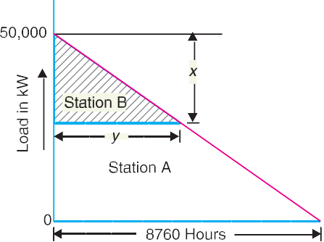

**84** Prin ciples of Power System

Let *x* = Installed capacity of station *B* in kW

*y* = Hours of operation of station *B*

 Installed capacity of station *A* = (50,000  *x*) kW

Units generated/annum by station *B* = 1 *xy*  1  *x*  8760 * *x* = 0·0876 *x*2

2 2 50,000

Unit generated/annum by station *A* = 1  50,000  8760  0·0876 *x*2

2

= 219  106  0·0876 *x*2

Annual cost of station *B*, *C* = Rs (50,000 + 50 *x* + 0·03  0·0876 *x*2)

*B*

= Rs (50,000 + 50 *x* + 0·00262 *x*2)

Annual cost of station *A* , *C* = Rs (75,000 + 80 (50,000  *x*) + 0·02 (219  106  0·0876 *x*2)

*A*

= Rs (8·455  106  80 *x*  0·00175 *x*2)

 Total annual operating cost of stations *A* and *B C* = *CA* + *CB*

= Rs (50,000 + 50 *x* + 0·00262 *x*2) + (8·455  106  80 *x*  0·00175 *x*2)

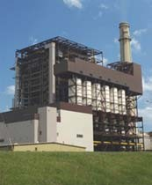= Rs (85,05,000  30 *x* + 0·00087 *x*2)

For minimum annual operating cost, *dC* = 0

*dx*

 *dC*

*dx*

= 0  30 + 2  0·00087 *x*

or 0 = 30 + 0·00174 *x*

or *x* = 30 = 17,241 kW

0  00174

 Capacity of station *B* = **17,241 kW**

Capacity of station *A* = 50,000  17,241

## = 32,758 kW

No. of hours of operation of station *B* is

*y* = 8760*x*  8760  17,241

50,000

## = 3020 hours

50,000

Steam Power Station

TUTORIAL PROBLEMS

**1.** A distribution transformer costing Rs 50,000 has a useful life of 15 years. Determine the annual depreciation charge using straight line method. Assume the salvage value of the equip- ment to be Rs 5,000.

**[Rs 3,000]**

* *y*  *x*

8760 50,000

 *y* = 8760 *x*

50,000



Economics of Power Generation **85**

1. The power generation equipment of a power station cost Rs 15,75,000 and has a useful life of 25 years. If the salvage value of the equipment is Rs 75,000 and annual interest rate is 5%, determine annual amount to be saved by sinking fund method. **[Rs 31,400]**
2. A 500 kVA distribution transformer costs Rs 50,000 and has a useful life of 20 years. If the salvage value is Rs 5,000 and annual compound interest rate is 8%, determine the value of the transformer at the end of 10 years using sinking fund method. **[Rs 35,700]**
3. A generating station has a maximum demand of 10 MW. Calculate the cost per unit generated from the following data :

Annual load factor = 35%

Capital cost = Rs 12,50,000 Annual cost of fuel and oil = Rs 8,00,000 Taxes, wages and salaries = Rs 7,00,000 Interest and depreciation = 10%

1. From the following data, estimate the cost per kWh for the generating station : Plant capacity = 50 MW

Annual load factor = 40%

Capital cost = Rs 12  106

Annual cost of wages, taxes etc = Rs 4,00,000 ; cost of fuel, lubrication, maintenance = Rs 17,52,000 ; Annual interest and depreciation = 10% of initial value. **[1·913 paise per kWh]**

1. In a particular area both steam and hydro stations are equally possible. It has been estimated that capital costs and running costs of these two types will be as under :

*Plant Capital cost*/*k W Running cost*/*kWh Interest*

Hydro Rs 3000 3 paise 5%

Steam Rs 2000 10 paise 5%

If the expected average load factor is 40%, which is economical to operate, steam or hydro ?

## [Hydro]

1. The energy cost of a 100 MW steam station working at 40% load factor comes out to be 12 paise/kWh of energy generated. What will be the cost of energy generated if the load factor is improved to 60% ? The fuel cost of the power station due to increased generation increase the annual generation cost by 5%.

## [8·4 paise]

1. A load having a peak value of 50 MW and 45% load factor is to be supplied by a steam power station in conjunction with a hydro-power station, the latter supplying 60 million units of en- ergy per annum with a maximum output of 20 MW.
   1. Capital cost Steam : Rs 2000 per kW installed Hydro : Rs 3000 per kW installed
   2. Cost of fuel Coal Rs 150 per metric ton ; consumption being 0·5 kg per unit generated
   3. Maintenance charges Steam : 0·7 paise per unit Hydro : 0·5 paise per unit
   4. Interest and depreciation Steam : 10% per annum

Hydro : 9% per annum

Calculate the average cost of energy. **[11·6 paise]**



GO To FIRST

**86** Prin ciples of Power System

# SEIF-TEST

## Fill in the blanks by inserting appropriate words/figures.

* 1. Depreciation is the ............ in value of equipment due to ...........
  2. The cost of electrical energy can be divided into three parts *viz.,* ............ and ...........
  3. The number of units generated will be more if the load factor is ............
  4. Semi-fixed cost is directly proportional to on power station.
  5. The running cost is directly proportional to ................
  6. In the diminishing value method, depreciation charges are heavy in years.
  7. The annual deposit is in sinking fund method as compared to straight line method.

## Pick up the correct words/figures from the brackets and fill in the blanks.

* 1. Fixed cost of electrical energy ............. maximum demand. (*depends upon, does not de- pend upon*)
  2. For the same maximum demand, if load factor is decreased, the cost of energy is .............

(*increased, decreased, not affected*)

* 1. Average load is ............... if the load factor increases. (*increased, decreased*)
  2. The annual, cost is due to the annual cost of fuel, oil, taxation, wages and sala-

ries to the operating staff. (*running, fixed*)

ANSWERS TO SELF-TEST

1. (*i*) decrease, wear and tear, (*ii*) fixed, semi-fixed, running cost, (*iii*) more, (*iv*) maximum demand

(*v*) units generated, (*vi*) early, (*vii*) smaller.

1. (*i*) does not depend upon, (*ii*) increased, (*iii*) increased, (*iv*) running.
2. Explain the terms interest and depreciation as applied to economics of power generation.

CHAPTER REVIEW TOPICS

1. Discuss the different classifications of costs of electrical energy.
2. Give the basis for expressing the cost of electrical energy as *a* + *b* kW + *c* kWh and explain the factors on which *a*, *b* and *c* depend.
3. Discuss the various methods of determining the depreciation of the equipment.
4. Enlist the effects of high load factor on the operation of power plants.
5. Write short notes on the following :
   1. Advantages of high load factor.
   2. Sinking fund method of depreciation.
   3. Three-part form of cost of electrical energy.

DISCUSSION QUESTIONS

1. What is the importance of interest on capital investment in calculating the cost of electrical energy ?
2. What is the significance of depreciation in the economics of power generation ?
3. Why is fixed cost independent of maximum demand and units generated ?
4. How does high load factor reduce the variable load problems on the power station ?